AI Use Declaration Form
Course: Introduction to Artificial Intelligence
Lab Title: Lab 1 Part A — Uninformed Search Algorithms
Student Name: Gabriel Akurang
Student ID: 35882028
GitHub Repository Link: https://github.com/Akurang/Akurang_Gabriel_Lab0.git
Date Submitted: June 5th 2026

1. AI Use Summary
Question | Student Response
Did you use any AI tool for this lab? | YES
Estimated percentage of the work influenced by AI | 18-23%
Did you attach evidence of AI use where applicable? | YES

2. Details of AI Use
Complete the table below for each AI tool used. Add more rows where necessary.
Name of AI Tool Used | Purpose for Using the Tool | Prompt or Instruction Given to the Tool | Part(s) of the Work Influenced by the Tool | How I Verified, Edited, or Improved the AI Output
Google AI | To understand the question and also to provide sample code for the various task similar to the code provided for us in lab_0.md |  |  | I made use of the library documentation and stack overflow to make sure there were no errors and for verification purposes.
Chatgpt | To fix errors and ensure the code was improved upon to be concise and readable. |  |  | This was used as a guide for Ex4 to 7, to ensure that code written was corrected when I got an error. Edits were done were possible to make sure they were in line with my initial understanding of the problem.

3. Attachment of AI Output Evidence
Where required, attach evidence of AI use. Tick all that apply. Add more rows where necessary.
Evidence Type | Attached? (Yes, No, N/A) | File Name
AI-generated draft | o
Prompt history | no
Screenshot of AI interaction | yes
Exported AI conversation | no
AI-generated code snippet | yes
Revised version showing student input | yes

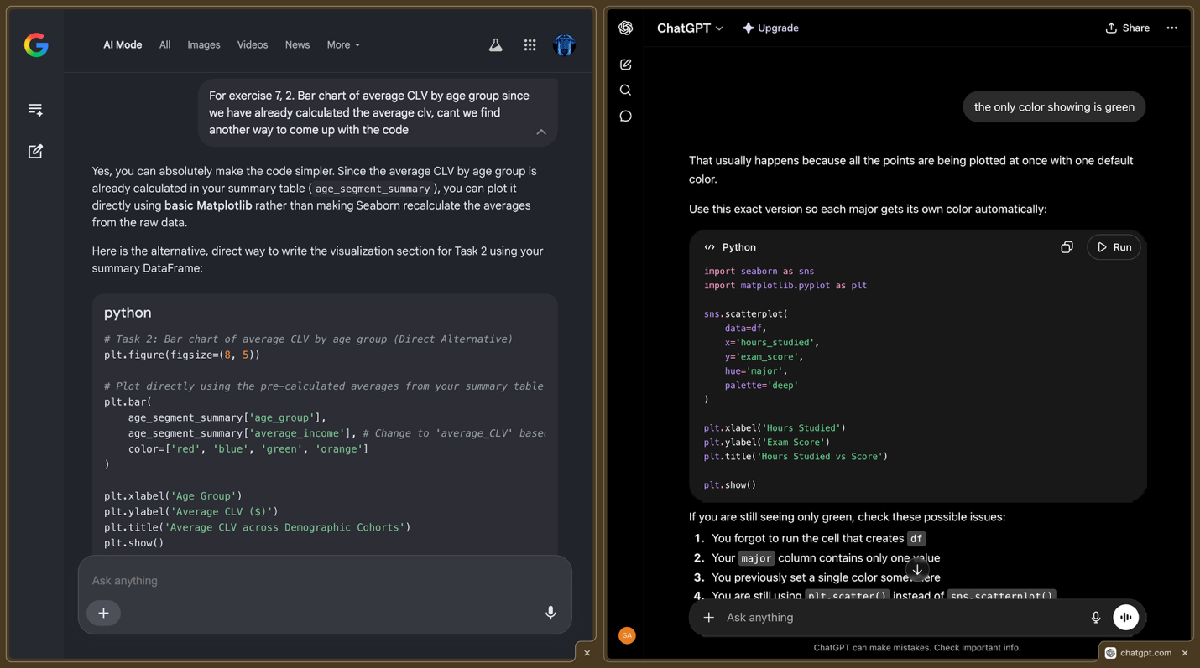

4. Student Declaration
I declare that:
Declaration Statement | Response (Yes/No)
The submitted work is my own work. | yes
Any use of AI tools has been clearly declared in this form. | yes
The prompts, instructions, and AI-generated outputs have been disclosed where applicable. | yes
I reviewed, tested, edited, and improved any AI-generated content before submission. | yes
My AI usage does not exceed 25% of the entire work. | yes
I understand that undeclared or excessive AI use may be treated as academic misconduct. | yes

Student Signature: GAKT
Date: June 5th 2026

